Day-3 Assignment
Name Mayank sharma
Uid 22BCS16224
Batch 4

Task: Create a document providing all steps for publishing using self-contained and dependent mode

Step 1: Create a new solution
Step 2: Write some code in it to run. For example:-
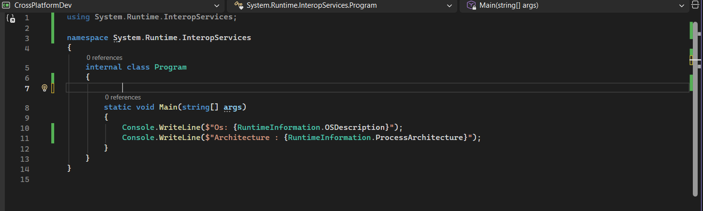

Step 3: Build and compile to check for errors.
Step 4: In the Solution Explorer, Right Click on the solution name and select Publish.
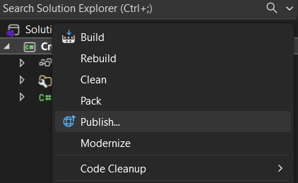

Step 5: After that if you have already published before it will lead you to your previous published profile or else you will be prompted to create a new one.
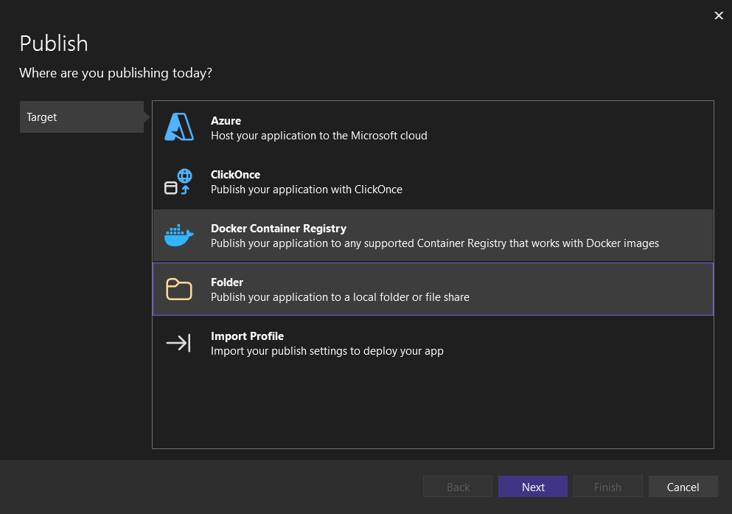

Step 6: Select the location where you want to publish your application.
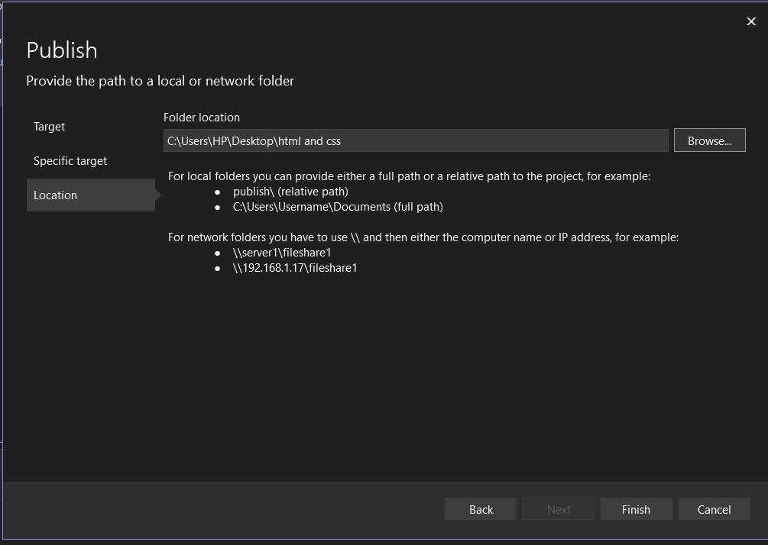
Step 7: A new profile is created for you to publish. Click on More Actions->edit to edit your preferences.
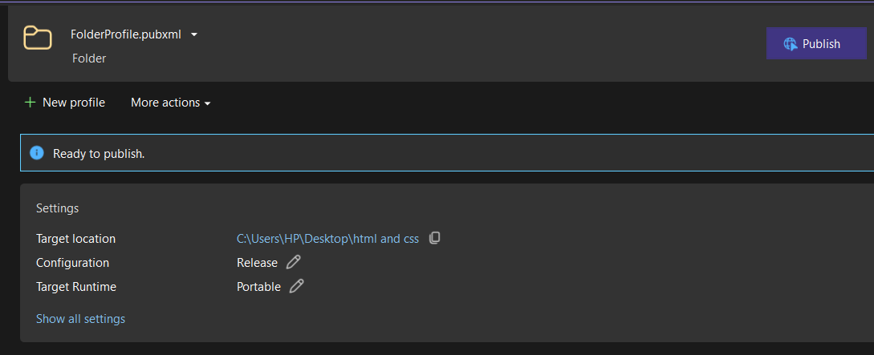
Step 8: For Self-contained application select portable in target runtime and for dependent application select the specific OS you want to run it on.
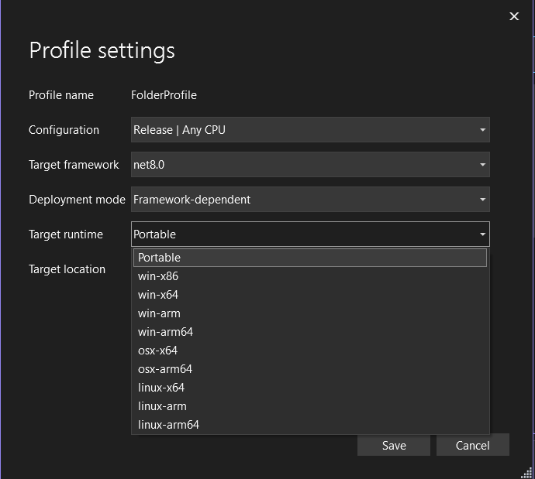

Step 9: Click on Publish button after saving all your preferences. The application will be created in your target folder.

